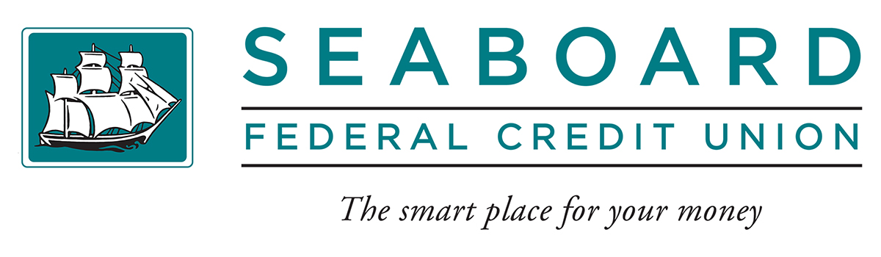

BID NOTICE

I, , hereby submit the following bid for one
2019 Toyota Tacoma Crew Cab, now in the possession of Seaboard Federal Credit Union.

$

The bid is based on “as is where is” and Seaboard Federal Credit Union makes no representation of the conditions of the unit and we have the right to reject any and all bids.

The vehicle may be seen at our Ellsworth office, 200 Main Street Ellsworth, ME 04605 at any time.

Bids will be opened on March 28th, 2025.

Signature

Date

Telephone Number

Main Office • 177 Main Street • P.O. Box G • Bucksport, ME 04416 • 207.469.6341 • 207.469.2866 fax • 800.639.2206 toll free
Ellsworth Branch • 200 Main Street • P.O. Box 115 • Ellsworth, ME 04605 • 207.667.8285 • 207.667.6848 fax
Hermon Branch • 2410 Route 2 • P.O. Box 6359 • Hermon, ME 04401 • 207.848.9995 • 207.848.3555 fax
www.seaboardfcu.com • Email: info@seaboardfcu.com

