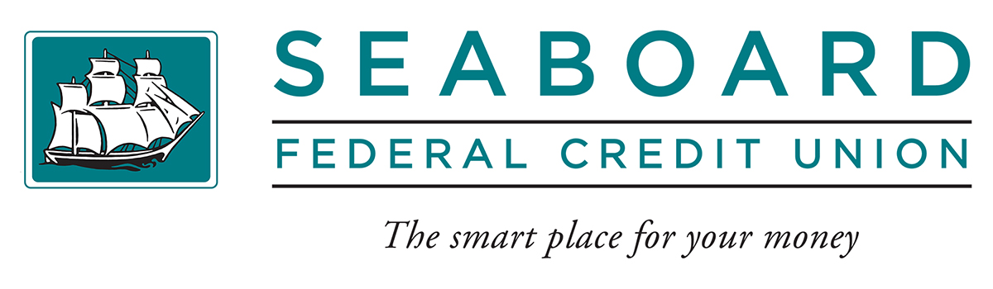
For Sale by Bid

2019 Toyota Tacoma Crew Cab 4WD

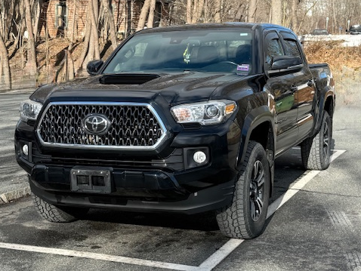

Mileage: 95,515
Engine: 3.5-Liter V6
Transmission: Automatic
Options: Power Windows & Locks, Cruise Control, Air Conditioned, Keyless Entry, Navigation, Backup Camera & Bluetooth, Floor Mats, Cargo Lamp, Receiver Hitch, Tonneau Cover.
Minimum Bid: $24,000

Stop into one of our three branches for more information and a bid sheet.
Bids will be accepted in sealed envelopes or emailed to info@seaboardfcu.com. The vehicle will be sold as is, where is with no written or implied warranty from Seaboard Federal Credit Union. Seaboard FCU reserves the right to refuse any and all bids.
Bids close Thursday March 27th at 4:30 PM.

Please Call Dani (ext. 1204) or Chad (ext. 1103)
at (207) 469-6341 for more information.
Main Office • 177 Main Street • P.O. Box G • Bucksport, ME 04416 • 207.469.6341 • 207.469.2866 fax • 800.639.2206 toll free
Ellsworth Branch • 200 Main Street • P.O. Box 115 • Ellsworth, ME 04605 • 207.667.8285 • 207.667.6848 fax
Hermon Branch • 2410 Route 2 • Hermon, ME 04401 • 207.848.9995 • 207.848.3555 fax
www.seaboardfcu.com • Email: info@seaboardfcu.com

